Pupil premium strategy statement

This statement details our school’s use of pupil premium (and recovery premium for the 2024 to 2025 academic year) funding to help improve the attainment of our disadvantaged pupils.

It outlines our pupil premium strategy, how we intend to spend the funding in this academic year and the effect that last year’s spending of pupil premium had within our school.

School overview
Detail | Data
School name | St James’ Primary School
Number of pupils in school | 409
Proportion (%) of pupil premium eligible pupils | 29/409 (7%)
Academic year/years that our current pupil premium strategy plan covers (3 year plans are recommended) | 2024-2025
Date this statement was published | October 2024
Date on which it will be reviewed | July 2025
Statement authorised by | Caryn Smith
Pupil premium lead | Sarah McKenzie
Governor / Trustee lead | Jill Arnold
Funding overview
Detail | Amount
Pupil premium funding allocation this academic year | £44,010 (£1480x28; £2570x1)
Recovery premium funding allocation this academic year | £ 0
Pupil premium funding carried forward from previous years (enter £0 if not applicable) | £ 0
Total budget for this academic year  If your school is an academy in a trust that pools this funding, state the amount available to your school this academic year | £44,010

Part A: Pupil premium strategy plan

Statement of intent
‘Inspiring and growing for fullness of life’.
At St James’ this statement really matters and is fundamental to our vision of the journey that pupils take at our school. We provide the highest quality education within the context of caring Christian belief and practices. Our children are all individual and unique; they have all been and are going on a different journey but our mission is to ensure that we develop the whole child, by implementing a blend of short, medium and long-term interventions. We believe in maximising the use of the pupil premium grant (PPG) by utilising a long-term strategy aligned to the SDP resulting in wider school improvements and increased readiness to learn. This also enables our children to grow for ‘Fullness of Life’, equipping them with skills to prepare them for the next stage in their education.
Overcoming barriers to learning is at the heart of our PPG use. We understand that needs and costs will differ depending on the barriers to learning being addressed. As such, we do not automatically allocate personal budgets per pupil in receipt of the PPG. Instead, we identify the barrier to be addressed and the interventions required, whether in small groups, large groups, the whole school or as individuals, and allocate a budget accordingly.
Our priorities
Setting priorities is key to maximising the use of the PPG. Our priorities are as follows:
- Ensuring high quality teaching in every class
- Closing the attainment gap between disadvantaged pupils and their peers
- Providing targeted academic support for pupils who are not making the expected progress
- Addressing non-academic barriers to attainment such as attendance and behaviour
- Ensuring that the PPG reaches the pupils who need it most

Challenges

This details the key challenges to achievement that we have identified among our disadvantaged pupils.
Challenge number | Detail of challenge
1 | Some pupils join SJP with poor speech and language development which has affected their communication and oracy skills. Language acquisition and vocabulary can be limited.
2 | The attainment gap between PP and non-PP is not narrowing or closing.
3 | Some pupil premium children and their families are more likely to need pastoral support. There is a growing need for support with social, emotional and mental health; complex family circumstances; and financial difficulties.
4 | Some pupil-premium pupils do not have rich and varied experiences.
5 | Attendance and poor punctuality can cause a significant loss of learning time for pupils. Attendance: 38% of PP children with attendance below 95% compared with 28% of non-PP. Absence rate for PP was 3.9% compared with 3.5% for non-PP.
6 | Pupils in receipt of Pupil Premium are also more likely to have SEND: 21% of children in receipt of PP also have SEND compared with 13% of non-PP

Intended outcomes
This explains the outcomes we are aiming for by the end of our current strategy plan, and how we will measure whether they have been achieved.
Intended outcome | Success criteria
Continue to improve pupils’ oracy skills in order to ensure children have the confidence and skills to communicate effectively | - Assessments and observations indicate significantly improved spoken language amongst disadvantaged pupils.
Close the gap between Pupil Premium and Non-Pupil Premium pupils for GLD, Phonics Screening, end of KS1 SATs Outcomes and end of KS2 SATs outcomes. | - Outcomes will show that an increased number of disadvantaged pupils meet the expected standard. Analysis of interventions will show that interventions have had a positive impact on learning
To meet the social, emotional and pastoral needs of all identified pupils  Families and children are supported with their mental health, emotional well-being and resilience. | - Families say that the support they receive is helpful.  - Children make tangible progress in terms of their mental health and well-being so they are ready to learn
Provide opportunities to experience and enjoy wider world learning  To provide enriched learning through specialists and experiences  To support unmet needs – (subsidize uniform, clubs, trips) | - All children will participate in school residential trips  - More PP children will attend a range of school based clubs  - Children can say why they have enjoyed enrichment opportunities  - Some PP children will access bursaries for music tuition.  - Pupil Premium children will represent the school at events and participate in all trips, both day and residential.  - Families feel well supported and there are positive relationships between school, families and the community.
To achieve and sustain improved attendance for all pupils, particularly our disadvantaged pupils, closing the gap between PPG and non-PPG. | - Improved attendance by July 2025 demonstrated by: the attendance gap between PP pupils and their non-PP peers to close (currently a gap of 0.4% - both are above national figures)  - PP attendance target: 95%
Use ongoing assessment more precisely to identify the exact development areas for individual children | - Interventions will have a positive impact on pupil outcomes.  - All PP children will be accessing interventions to provide support and challenge

Activity in this academic year
This details how we intend to spend our pupil premium (and recovery premium funding) this academic year to address the challenges listed above.

Teaching (for example, CPD, recruitment and retention)
Budgeted cost: £0 (covering CPD in-house rather than external supply)
Activity | Evidence that supports this approach | Challenge number(s) addressed
Tailored CPD delivered to all staff in approaches to the teaching of phonics and maths:  -Mastering Number at KS1  -Number Sense Times Tables Fluency  -The Five Big Ideas for Mastery  -Precise vocabulary; sentence stems and generalised sentences | CPD provided to all teaching staff to develop and deepen subject knowledge  https://educationendowmentfoundation.org.uk/supportforschools/school-improvement-planning/1-high-qualityteaching | 1, 2, 6
Pupil intervention conferences  Strengthen the use of ongoing assessment to precisely identify the exact development areas to focus on individual children  Track progress and the impact of interventions closely through PIC meetings – proforma developed; Phase Leader analysis; CPD for staff; | ‘Some pupils may require additional support alongside high-quality teaching in order to make good progress. The evidence indicates that small group and one to one interventions can be a powerful tool for supporting these pupils when they are used carefully’. https://educationendowmentfoundation.org.uk/supportfor-schools/school-improvement-planning/2-targetedacademic-support | 2, 6
CPD for all teaching staff on developing the use of oracy in the curriculum (full implementation of Voice 21) | Oracy is linked with: -cognitive gains, e.g. improved academic attainment. -personal and social gains including increased self-esteem and confidence. -civic engagement and empowerment. (Chartered College’s summary of evidence of the importance of oracy.  In Voice 21 Oracy Schools: 77% of teachers say oracy education has boosted attainment 84% of teachers say teaching and learning has improved with oracy. 89% of students agree that speaking and listening has helped them progress with their school work. | 1
To use collaborative learning approaches which are structured and well-designed to improve outcomes for children. | https://www.kaganonline.com/free_articles/research_and_rationale/282/Kagan-Structures-Research-and-Rationale#:~:text=They%20report%20positive%20outcomes%20for,they%20begin%20using%20the%20structures  https://educationendowmentfoundation.org.uk/education-evidence/teaching-learning-toolkit/collaborative-learning-approaches | 1, 2, 3, 6

Targeted academic support (for example, tutoring, one-to-one support structured interventions)
Budgeted cost: £ 14,584
Activity | Evidence that supports this approach | Challenge number(s) addressed
Phonics  Additional support in EYFS and KS1  ELS intervention groups in place for those that have been identified as at risk of not passing the PSC in Y1 and those that did not pass in Y2 | Phonics approaches have a strong evidence base indicating a positive impact on pupils, particularly from disadvantaged backgrounds. Targeted phonics interventions have been shown to be more effective when delivered as regular sessions over a period up to 12 weeks:  Phonics | Toolkit Strand | Education Endowment Foundation | EEF | 1, 2, 6
Use the Nuffield Early Language Intervention (NELI) to improve children’s language and early literacy skills. | Robust evaluations found NELI children make on average 3 months of additional progress in language.  https://educationendowmentfoundation.org.uk/education-evidence/early-years-toolkit/communication-and-language-approaches | 1, 2, 4, 6
TAs to provide additional support in KS2 to help narrow the gap.  Details of interventions outlined on PIC forms and SEND support plans | We will use TAs to improve quality first teaching, deliver effective interventions and develop children’s skills such as independence.  ‘When the adults change – Paul Dix’ https://d2tic4wvo1iusb.cloudfront.net/eef-guidance-reports/teachingassistants/TA_Guidance_Report_MakingBestUseOfTeachingAssistantsPrintable_2021-11-02-162019_wsqd.pdf?v=1672272457  https://educationendowmentfoundation.org.uk/educationevidence/teaching-learning-toolkit/teaching-assistant-interventions | 1, 2, 3, 4, 6
Social and emotional interventions  Drawing and Talking  Lego  Exploring feelings  Emotion Coaching  Bespoke pastoral support  Forest School  Mentoring programme – Cheltenham Town Football | https://educationendowmentfoundation.org.uk/education-evidence/teaching-learning-toolkit/social-and-emotional-learning | 3, 5
Family Support Worker and Mental Health and Well-Being  Identify families who need support and provide this through the pastoral team and external agencies, e.g. Early Help, Young Minds Matter.  Family Support Worker to provide targeted intervention where needed | https://assets.publishing.service.gov.uk/government/uploads/system/uploads/attachment_data/file/1064758/Supporting_Families_-_Effective_practice_and_service_delivery_-_Learning_from_local_areas.pdf  https://www.ncb.org.uk/sites/default/files/uploads/attachments/20210513_Rapid%20Review_Full%20Report%20-%20FINAL.pdf | 3, 4, 5, 6

Wider strategies (for example, related to attendance, behaviour, wellbeing)
Budgeted cost: £ 30,244
Activity | Evidence that supports this approach | Challenge number(s) addressed
Pastoral Teacher to support pupils to demonstrate positive learning behaviours in the classroom | Identified pupils are ready to learn and have strategies to use when they are not regulated.  https://educationendowmentfoundation.org.uk/education-evidence/teaching-learning-toolkit/mentoring | 1, 2, 3, 5, 6
Subsidize the cost of residential and other visits | There is a wider evidence base indicating that outdoor adventure learning may have positive impacts on other outcomes such as self-efficacy, motivation and teamwork. Outdoor adventure learning may play an important part of the wider school experience, regardless of any impact on academic outcomes.  https://educationendowmentfoundation.org.uk/education-evidence/teaching-learning-toolkit/outdoor-adventure-learning | 3, 4
Subsidize the cost of sporting and after school clubs/trips/music tuition  Audit the participation of Pupil Premium children in school clubs and extra-curricular activities.  Additional Forest School PP groups for 4x45mins per year group for PP children | https://educationendowmentfoundation.org.uk/education-evidence/teaching-learning-toolkit/arts-participation  https://educationendowmentfoundation.org.uk/education-evidence/teaching-learning-toolkit/outdoor-adventure-learning | 3, 4
Pates Shaping Futures Programme.  Collaborate with Pates to nurture the aspirations of students so that they reach their future potential.  (4x Y5 pupils) | In place for three successful years, after which 100% of Shaping Futures students reported increased confidence in their core Mathematics and English lessons | 2, 3, 4
Parent/Pupil Liaison project  Monitor and refine systems in place to help us to identify those families who may need some additional support.  Identify children who may benefit from pastoral support. | Embedding principles of good practice set out in the DfE’s Improving School Attendance advice.  The DfE guidance has been informed by engagement with schools that have significantly reduced levels of absence and persistent absence.  https://educationendowmentfoundation.org.uk/education-evidence/evidence-reviews/attendance-interventions-rapid-evidence-assessment  This rapid evidence assessment examines the existing research on interventions that aim to improve pupils’ school attendance and the characteristics of these interventions, based on a systematic search of existing literature.  https://d2tic4wvo1iusb.cloudfront.net/documents/pages/Attendance-REA-report.pdf?v=1647348064 | 2, 3, 5, 6
Funding various resources:  PE kit/popcorn club/Book Bags etc  Milk for PP children  Uniform | 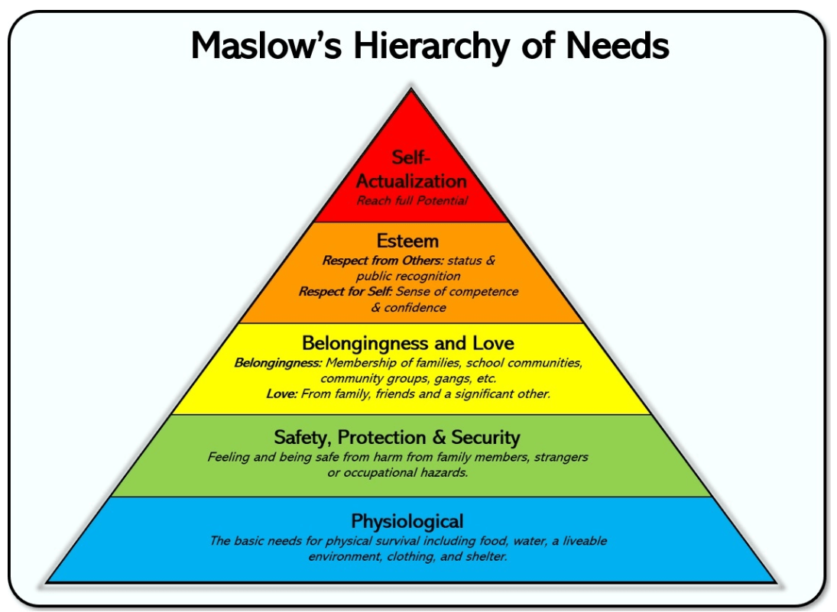 | 3, 4
Work with families to improve attendance  Analyse attendance data to identify pupils and cohorts that require support  Build strong relationships with families, listen to and understand barriers and work to support their removal  Create bespoke attendance improvement plans | Embedding principles of good practice set out in the DfE’s Improving School Attendance advice.  https://educationendowmentfoundation.org.uk/education-evidence/evidence-reviews/attendance-interventions-rapid-evidence-assessment  interventions, based on a systematic search of existing literature.  https://d2tic4wvo1iusb.cloudfront.net/documents/pages/Attendance-REA-report.pdf?v=1647348064 | 2, 3, 4, 5, 6, 7
Total budgeted cost: £ 44,828

Part B: Review of outcomes in the previous academic year

Pupil premium strategy outcomes
This details the impact that our pupil premium activity had on pupils in the 2023 to 2024 academic year.

Data and Statutory Assessments
Pupil Premium Outcomes:

EYFS
100% PP GLD
Children have received additional support for interventions where appropriate.
Phonics Screening Check:
Y1 Phonics Screening Check
PP 50% passed.
Y2 Phonics Screening Check:
Phonics screening re-take. PP 50% passed.
Year 4 Multiplication Check
 | All | Pupil Premium | Non Pupil Premium
Average Score | 22 | 24 | 22
% full marks | 37% | 60% | 35%
% >20 | 78% | 100% | 78%

End of KS2*
 | Percentage of pupils achieving the expected standard |  |  | Average scaled score
 | School | Pupil Premium | Nationally | School | Nationally
Reading | 80% | 100% | 74% | 107 | 105
GPS | 78% | 100% | 72% | 106 | 105
Maths | 78% | 100% | 73% | 105 | 104
Writing | 75% | 100% | 71% | N/A | N/A
Science | 78% | 100% | 81% | N/A | N/A

Progress for PP children from EYFS-Y6
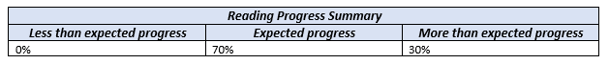
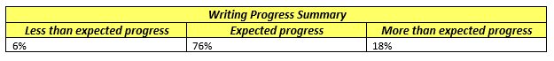
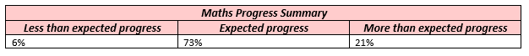

Strengths | Areas for development | Next steps
EYFS – 100% of PP are typical for reading, writing and maths  Y4 – for reading and writing, the PP children have exceeded the DGAT targets set and are in line with them for Maths  Y6 – 100% of PP are GDS for reading, writing and maths  Reading – 100% children made expected or greater than expected progress.  Maths and Writing - 94% children made expected or greater than expected progress.  ELS interventions in KS1 have supported the progress with phonics and reading  ELS interventions and reading interventions to support fluency have been In place for some PP children in KS2 and have supported progress.  Pastoral support has enabled some of these children to be ready to learn, e.g. Forest School, Drawing and Talking, Play Therapy, Lego Play.  Maths interventions in upper KS2 linked to gaps identified in assessments.  Reading mentor from Cheltenham Town has supported reading progress for 2 children in KS2.  Phonics Screening Check – some specific examples of excellent progress being made, e.g. one child moving from 0 to 37. | With the exception of EYFS and Y6, there is still a gap in the level of attainment between PP and non-PP  Phonics Screening – there is a gap in attainment between the PP and non-PP  Review impact of interventions outlined and reviewed on PIC forms. | Mastering Number across EYFS and KS1  Times tables fluency across KS2 with one to one interventions and self-quizzing in place  ELS interventions to continue (one to one) in KS1 and where appropriate in KS2 – CPD  Pre-teaching for some PP children, especially in year groups where the gaps are wider.  Review PICs and small steps  Review Forest School provision

Targeted Interventions
Social and Emotional
Interventions were planned out every half term by pastoral team in response to the needs of the children and any gaps in learning, e.g. academic, Fizzy, cooking, drawing and talking. Positive relationships were formed, children’s confidence grew, they developed strategies to support themselves when things were difficult and they were experiencing big feelings.

KS2 Interventions (10x afternoons per week)
Gaps have been identified by teachers following lessons and assessments and used to inform interventions during the afternoon sessions. These interventions have been planned during our PIC meetings and have been used for phonics, reading, writing and maths. There have been positive outcomes for the children (see Phase Data Reports and Pupil Premium Analysis).

Forest School
There have been many positive impacts for children who have been engaged with Forest School. Some pupil premium children have had sessions all year to support their social and emotional needs whereas others have participated with their classes.
Positive impacts:
Self-awareness –more aware of their physical selves, safely explore and test their own boundaries. They have developed skills, tested ideas and made discoveries.
Self-regulation – children have experienced the emotions that go with challenging themselves, taking risks, achieving something and failing at something. By providing a safe environment in which to experience these emotions, children have been learning how to manage them successfully.
Social skills –working together, sharing tools and playing together, operating outside of the constraints or rules of the classroom. Children have collaborated and collectively achieved goals. This has been particularly powerful for our EAL children.
Empathy – this has developed through supporting each other and developing an understanding that some things may be more challenging for some members of the team than others.
Motivation – Chris has developed a fascinating environment for children to play and learn in. Curiosity and keenness to explore often trigger an eagerness to participate, freedom from “being wrong” and willingness to have a go.

Wider Strategies
Family Support Worker – Move More
6 Webinars  (Number of parents registered) | 36
School specific online sessions (number of parents who either attended live or watched the recordings) | 80
Family programmes (number of programmes shared) | 3
Facebook group (number of parents that joined) | 2
1-1 Support (number of families) | 14
Coffee afternoon (Number of parents attended) | 4
Newsletters (number shared with the school) | 6
Staff support sessions (number of sessions) | 5
Total number of families engaged in direct contact | 134
Webinars:
- Food and mood (Term 1)
- Steps for effective boundaries setting and dealing with defiance (Term 2)
- How to support an overwhelmed and worried child (Term 3)
- Managing tantrums, meltdowns and shutdowns: inevitable or avoidable? (Term 4)
- How to use movement to support children’s mental wellbeing (Term 5)
- Impact of body image on children’s mental well-being (Term 6)
Newsletters:
- How to use a “Healthy Mind Platter” to support your family’s well-being (Term 1)
- How to raise an appreciative child in the “I want (more)” world (Term 2)
- “My voice matters” – empowering children to confidently express themselves (Term 3)
- Celebrating neurodiversity (Term 4)
- Strategies to help your child kick the “helpless” habit (Term 5)
- Keeping children safe when home alone and when venturing outside unsupervised (Term 6)

Health Challenges:
- Picky eaters family programme (Terms 1 and 2)
- The Lunch Bunch challenge (Terms 3 and 4)
- The Great Grow-off challenge (Terms 5 and 6)
School specific online sessions:
- How to handle the after-school meltdowns (Term 1)
- Boss your mornings (Term 4)
- When to seek professional help (Term 4)
- How to help your children prepare for, and cope with, change and transition (Term 6)
Impact:
Every single parent said that they found our sessions very useful and would recommend our services 100%

Emotion coaching
Emotion coaching and approaches outlined in our relationships policy have been used widely which has maintained positive relationships across the school.
CPD – KCA training for teachers and TAs

Young Minds Matter
Young Minds Matter support is being accessed by children when appropriate in school. This has been incredibly valuable and supportive with tangible improvements for individuals.

Pastoral Lead
Sessions with our pastoral lead have supported the emotional needs of pupils so that they make better progress in their learning and are able to feel calm and ready to learn. The children’s personal, social and emotional development has been supported, as well as their communication and language skills.

Enrichment
We have ensured that PP children have the same opportunities for enrichment outside of the curriculum that non PP children get through supporting the funding of school based clubs/afterschool clubs/trips that may require payment. This has included Move More holiday clubs being provided for some families.
We have supported the funding of school residential. All PP children were able to take part in Y5 and Y6.
PP children have been part of many clubs which has had a positive impact on them socially, emotionally and in terms of their well-being.

Attendance
We have improved persistent absenteeism rates for pupils through targeted family support and rigorous monitoring od attendance. Regular meetings between pastoral team, DHT, HoS and Exec Head focused on vulnerable children and attendance meant we were proactive at addressing any concerns and supporting families. Overwhelming success with improving attendance over the year (see minutes of meetings)

Externally provided programmes
Programme | Provider
Voice 21 Oracy Project | Voice 21
NELI – Nuffield Early Learning Intervention | Nuffield
Can Do Maths | Buzzard Publishing
Specialist Knowledge for Teaching Mathematics TA Programme - TRG | GLOW
Essential Letters and Sounds | Oxford University Press
NPQH, NPQSL, NPQLM | Odyssey and Balcarras
Primary Mastery Specialist | NCETM
Oracy in Maths | GLOW

Service pupil premium funding (optional)
Measure | Details
How did you spend your service pupil premium allocation last academic year? | Interventions to provide pastoral support. We identified any needs and gaps which we addressed with targeted support.
What was the impact of that spending on service pupil premium eligible pupils? | Children appeared settled, engaged and built positive relationships.

Further information (optional)
Use this space to provide any further information about your pupil premium strategy. For example, about your strategy planning, or other activity that you are implementing to support disadvantaged pupils, that is not dependent on pupil premium or recovery premium funding.

