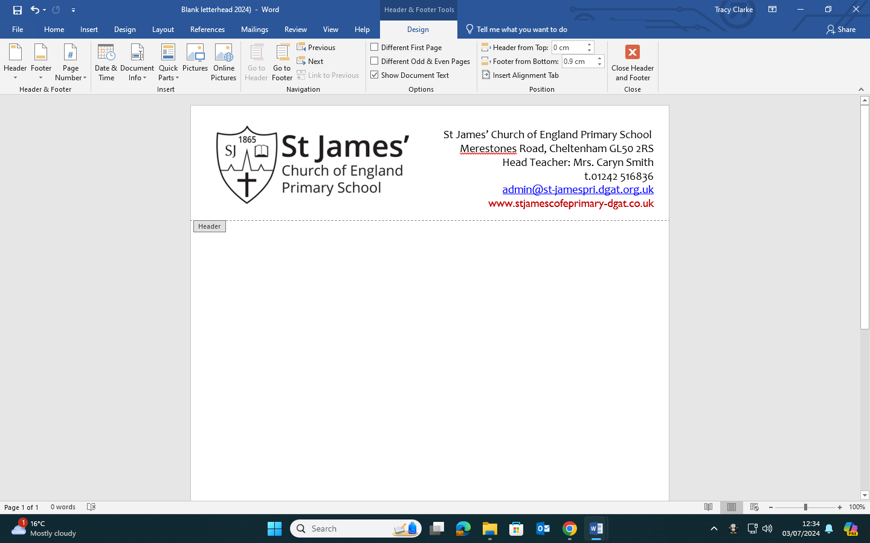

Dear Parents/Carers, 6th September 2024

Extra-curricular Activities – Autumn term 1st half 2024 – Start from 16th September 2024

We are pleased to be able to provide the following extra-curricular activities for Autumn term 1st half, Monday 16th September to Friday 25th October 2024. Clubs that have a maximum amount of spaces available, space is on a first come first served basis.

If your child wishes to attend a club, register your interest by submitting the google form by Wednesday 11th September. If your child is attending Cheltenham Town or Just camps, you do not need to let us know on the form. The link to the google form is:
https://forms.gle/hDT91sLFvgzbfrkA6

You must contact external clubs (Cheltenham Town and Just Camps) separately for payment, refer to their website for payment instructions, registration and dates clubs will be running. If your child is absent on the day of the club, through illness, we will notify the club. If your child will not be attending the club for other reasons, you must contact the external provider direct to notify them that your child will not be attending.

Cheltenham Town Football- To book and pay for a place, visit https://officialsoccerschools.co.uk/cheltenhamtownfc/

Just Camps - To book and pay for a place register at www.justcamps.co.uk/register

Monday Gloucestershire Cricket-This club is full and is only for members who have registered. If your child wishes to wear their All star t-shirt, they can bring named t-shirt to school, in their bag, and get changed into the t-shirt after school.

Tuesday Politics and Debating Club - Year 5 and 6 only. Location in Class 9 - Eat lunch first, club starts at 1pm prompt- 1.30pm. This club is to understand the importance of using your voice to share your opinions respectfully and to listen to the ideas of others. There is an expectation some preparation/discussion/research will take place at home to support the conversations.

Tuesday Maths club-This club will be run by Mrs Reiner, for Year 5, and will start from 1st October. For registration, payment information and dates, see Mrs Reiner’s leaflet. To register, text 07988821800 stating name of your child, parent name and email address. Club will not run on 10th December

Wednesday Choir- This is open to Years 1 to year 6. However, only Year 5 and 6 will be participating in the Young voices concert scheduled for Friday 31st January 2025, at the NEC in Birmingham.

Wednesday Sportily club-This is an alternative sports club where the children will have an opportunity to play sport and talk about life in a reflective space. This club is free, is open to Years 5 and 6. Please note this club is not running on 25th September.

Future clubs (not included on google form and are subject to change)
Term | Club | Year group | Time | Day | Staff
Spring | Lego | TBC | Lunchtime | TBC | Mr Bradley
 | Friendzone | 3 | Lunchtime | TBC | Mrs Williams
 | Papercraft  1st half term | 2 | 3-4pm Class 4 | Weds | Mrs Wagstaff  Mrs Suwart
 | Papercraft  2nd half term | 1 | 3-4pm Class 4 | Weds | Mrs Wagstaff  Mrs Suwart
 | Maypole  2nd half term | 2 | Lunchtime | Tues | Mrs Hobbs  Miss Woodward
 | Cycling | Rec, Yr 1,2 | 3-4pm | Thurs | External provider
 | Dance club  Preparation for Feet First Dance Festival | 1-6 | TBC | TBC | Mrs Pullen/Miss Dunn
 | Pet Awareness | TBC | TBC | TBC | Mrs Avery
 | Art | TBC | 3-4pm | TBC | Mrs Sutch
Summer | Drama | TBC | 3-4pm | TBC | Mr Payne
 | Maths | TBC | Lunchtime | TBC | Mrs McKenzie

PE Kit-Children attending a club involving sporting activity, will need to come to school in their PE kit (no football kits) as there will be no provision for getting changed after school for the club. Wear trainers and not astro football boots.

After the club, children will be brought out via the main gate, or main front entrance door if indoor club.

We do our best to let you know if any school club has to be cancelled. Any last-minute cancellations will be communicated to you primarily by text message. If we cannot do this, your child will be supervised until normal collection. If you are unsure if your child’s club is cancelled due to bad weather, contact school on the day after 2pm.

Yours sincerely,
Mrs C Smith
Headteacher

St James’ Autumn Term 1st Half 2024 – Extra-Curricular Clubs/Activities Timetable
Clubs run Monday 16th September to Friday 25th October 2024
Day | Club/Activity | Time/Venue | Person in charge of Club | Year Group | Club information
M  O  N  D  A  Y  T  U  E  S  D  A  Y  W  E  D  N  E  S  D  A  Y | Cheltenham  Town Football | 3-4pm  Field | Ryan Godwin  Cheltenham Town Football | 5,6 | Max 35  External Provider-Fee  https://officialsoccerschools.co.uk/cheltenhamtownfc/
 | Girls Only-Cheltenham  Town Football | 3-4pm  Field | Ryan Godwin  Cheltenham Town Football | 1,2,3,4,5,6 | External Provider-Fee  https://officialsoccerschools.co.uk/cheltenhamtownfc/
 | School Cricket Club | 3-4pm  Field | Gloucestershire Cricket | 1, 2 | Starts Mon 9th September  FULL-Only members who have registered are eligible to attend
 | STEM club | 3-4pm C11 | Mr Kellers  Mrs Earle-volunteer | 5,6 | FULL
 | Cheltenham  Town Football | 3-4pm  Field | Ryan Godwin  Cheltenham Town Football | 3,4 | Max 35  External Provider-Fee  https://officialsoccerschools.co.uk/cheltenhamtownfc/
 | Just Camps | 3-4pm  Playground | Matt Holdback  Just Camps | Rec, 1,2,3 | External Provider-Fee  www.justcamps.co.uk/register
 | Maths Club | 3.15-4.15pm  C11 | Mrs Reiner | 5 | FULL-Refer to Mrs Reiner for availability
 | Debating and Politics club | Eat lunch first  1-1.30pm  Class 9 | Mrs Allen | 5,6 | Max 18-No charge  Eat lunch first. Prompt arrival 1pm
 | Reflection spaces | Lunchtime | Mrs Harris  Mrs Baker | Whole school | You do not need to book a place for this club. Just go along!
 | Cheltenham  Town Football | 3-4pm  Field | Ryan Godwin  Cheltenham Town Football | 1,2 | Max 35  External Provider-Fee  https://officialsoccerschools.co.uk/cheltenhamtownfc/
 | Choir | 3-4pm  Hall | Mrs Knight Mrs Sutch  Mrs Long Miss Moore | 1 to 6 | FULL  Yr5/6 only can attend Young voices concert on 31st Jan 2025
 | Sportily Club | 3-4pm  Field | Sportily coach | 5,6 | Max 15-No charge  NOT RUNNING ON 25th September
T  H  U  R  S  D  A  Y | Reflection spaces | Lunchtime | Mrs Harris  Mrs Thomas | Whole school | You do not need to book a place for this club. Just go along!
 | Move More-Multi sports | 3-4pm-Hall | Move More | 1,2,3 | FULL
 | Yoga | 12.30-1pm-Hall | Mrs Wood  Mrs Philpotts | 4,5 | FULL  Bring packed lunch on the day
F  R  I  D  A  Y | Chess Club | 12.30-1pm  DT Room | Mr Smith-volunteer | 3,4,5,6 | Max 20  External provider-No charge
 | Cross Country | 8-8.30am  Field | Mrs Hanks | 3,4,5,6 | Arrive at main gate for 8am. Bring a towel (in case of wet weather)
 | Lego Club | 12.30-1pm  Class 10 | Miss Woodward | 4,5 | FULL
 | Library | 3-3.30pm  Library | Mrs Thompson | Whole school | Parents and children welcome  Borrow a book from junior library  You do not need to book, just go along!
 | Netball | 3-4pm  Playground | Mrs Smith | 5,6 | FULL
Just Camps –
Booking: www.justcamps.co.uk/register
https://www.justcamps.co.uk/
Email: admin@justcamps.co.uk

External Provider contact information-:
Cheltenham Town Football Club –
Website: Club Home Page | Official Soccer Schools
Booking: https://officialsoccerschools.co.uk/cheltenhamtownfc/
Email: info@ctfccp.com

