Pupil premium strategy statement

Before completing this template, you should read the using pupil premium guide and the appropriate example statement available on the pupil premium page.

Before publishing your completed statement, you should delete the instructions (text in italics) in this template, including this text box.

This statement details our school’s use of pupil premium (and recovery premium for the 2021 to 2022 academic year) funding to help improve the attainment of our disadvantaged pupils.

It outlines our pupil premium strategy, how we intend to spend the funding in this academic year and the effect that last year’s spending of pupil premium had within our school.

School overview
Detail | Data
School name | St James’ Primary School
Number of pupils in school | 417
Proportion (%) of pupil premium eligible pupils | 34/417 (8.2%)
Academic year/years that our current pupil premium strategy plan covers (3 year plans are recommended) | 2023-2024
Date this statement was published | October 2023
Date on which it will be reviewed | July 2024
Statement authorised by | Lisa Harford
Pupil premium lead | Sarah McKenzie
Governor / Trustee lead | Tracey Earle
Funding overview
Detail | Amount
Pupil premium funding allocation this academic year | £39,505
Recovery premium funding allocation this academic year | £
Pupil premium funding carried forward from previous years (enter £0 if not applicable) | £
Total budget for this academic year  If your school is an academy in a trust that pools this funding, state the amount available to your school this academic year | £39,505

Part A: Pupil premium strategy plan

Statement of intent
‘Inspiring and growing for fullness of life’.
At St James’ this statement really matters and is fundamental to our vision of the journey that pupils take at our school. We provide the highest quality education within the context of caring Christian belief and practices. Our children are all individual and unique; they have all been and are going on a different journey but our mission is to ensure that we develop the whole child, by implementing a blend of short, medium and long-term interventions. We believe in maximising the use of the pupil premium grant (PPG) by utilising a long-term strategy aligned to the SDP resulting in wider school improvements and increased readiness to learn. This also enables our children to grow for ‘Fullness of Life’, equipping them with skills to prepare them for the next stage in their education.
Overcoming barriers to learning is at the heart of our PPG use. We understand that needs and costs will differ depending on the barriers to learning being addressed. As such, we do not automatically allocate personal budgets per pupil in receipt of the PPG. Instead, we identify the barrier to be addressed and the interventions required, whether in small groups, large groups, the whole school or as individuals, and allocate a budget accordingly.
Our priorities
Setting priorities is key to maximising the use of the PPG. Our priorities are as follows:
- Ensuring high quality teaching in every class
- Closing the attainment gap between disadvantaged pupils and their peers
- Providing targeted academic support for pupils who are not making the expected progress
- Addressing non-academic barriers to attainment such as attendance and behaviour
- Ensuring that the PPG reaches the pupils who need it most

Challenges

This details the key challenges to achievement that we have identified among our disadvantaged pupils.
Challenge number | Detail of challenge
1 | Some pupils typically join SJP with poor speech and language development which has affected their communication and oracy skills. Language acquisition and vocabulary can be limited.
2 | Lower starting points on entry/ acquisition of early reading and maths
3 | Some pupil premium children do not always make as much progress as non-pupil premium in EYFS, Key Stage 1 and Key Stage 2 .
4 | Some pupil premium children are more likely to need pastoral support and can struggle emotionally as well as academically.
5 | Some pupil-premium pupils do not have rich and varied experiences as non pupil-premium pupils.
6 | Support at home can be limited as some families find it difficult to support their child’s learning at home due to a range of external factors.
7 | A growing need for support with social, emotional and mental health
8 | About a quarter of our Pupil Premium pupils also have Special Educational Needs
9 | A rising number of families are struggling financially due to the increased cost of living and this can impact pupils’ ability to concentrate and access learning.

Intended outcomes
This explains the outcomes we are aiming for by the end of our current strategy plan, and how we will measure whether they have been achieved.
Intended outcome | Success criteria
Improving teaching and learning for all pupils means that attainment and progress for all is improved | - Staff continually reflect on more aware of T&L practice and improve aspects so that children learn more and remember more  - T&L continually improves and links to current research  - Feedback and marking impact positively on learning  - Pupil lead learning successfully – they are able to discuss the impact  - Drivers, from our Spiritual Wheel, will be purposeful, underpin and enhance the curriculum.  - Magenta and Kagan principles embedded to give the children tools for learning, developing their resilience to ‘have a go’ and develop independent thinking and approaches, creating opportunities for all to achieve. Most children will be able to explain their thinking with more than one method/solution
The progress and attainment of Pupil Premium children is in line with non-pupil premium children with the same starting points. | - In PIC meetings, the attainment and progress of Pupil Premium children is discussed and support is planned.  - In each classroom, all Pupil Premium children are ready to learn whilst demonstrating high levels of motivation and engagement during lessons. Progress of children will be visible in learning walks, pupils’ books and when talking to children about their learning (pupil voice).  - Greater depth in all subjects is supported by an effective curriculum  - Teachers are confident with assessing children  - Mastery approach - structure of Maths lessons gives children the opportunity to develop a secure and deep understanding of concepts.  - Children’s work will show progression and they will learn and remember more  - Children who are struggling to evidence their reasoning and problem solving skills will be identified in each phase and interventions put in place accordingly (PIC meetings)  - Remember Its and Ready to Progress Assessments used to develop confidence with questions styles  - Progress rates at the end of key stages shows an upward trend  - Greater depth opportunities evident in pupils’ books
Strengthen the use of assessment to identify weaker areas and pinpoint the exact development areas to focus on individual children | - Strong use of assessment to identify weaker areas and pinpoint the exact development areas to focus on individual children.  - Assessments will be carried out to identify key areas of development. These can then be worked on to ensure gaps close and to allow a greater opportunity for children to ‘keep-up’ in lessons. Certain focus areas can be identified for low attaining pupils and these can be addressed during interventions or within the lessons. Assessment for Learning opportunities will be evident in all classrooms and teachers will be flexible when teaching, responding to the needs of the children, so that progress is maximised.
Aim for EYFS pupils to reach a good level of development on exit of EYFS | - Provision is strong as identified in HofS drop-ins and lesson observations as a result of training and support  - Teacher PFM details support and progress  - EYFS networks take place and are attended by staff- staff share out this role  - Supported effectively by SENDco  - Vulnerable groups team review EYFS pupils and provision  - Quality First Teaching and Learning across EYFS  - EYFS network time with DGAT and CLP support from the SEND and vulnerable group team to support/diagnose early needs
To improve children’s early language and develop oracy throughout the school. | - Use the Nuffield Early Language Intervention (NELI) is a programme for children in Reception (4-5 years) which has been found to improve children’s language and early literacy skills. Provide short, small-group and individual teaching sessions to around 3-6 pupils for 20-weeks.  - Robust evaluations found NELI children make on average 3 months of additional progress in language.  - Voice 21 will be used to develop children’s Oracy skills.
To further embed phonics teaching so that outcomes in Y1 for the Phonics Screening Check are at least in line with national measures. | - ELS will be used with fidelity  - In July 2024: 88% all children to be expected standard in Phonics Screening Check with 71% PP.  - ELS intervention groups in place for those that have been identified as at risk of not passing the PSC in Y1 and those that did not pass in Y2  - Phonics assessment timetable highlights children who need additional booster sessions
Aim for all KS1 pupils to make at least expected progress in years 1 and 2 and for pupil premium to at least in line with national measures. | - Rigorous basic skills approaches in place for maths, phonics, reading, spelling and grammar  - One-to-one and small group will be used to support disadvantaged pupils: creating additional teaching and learning opportunities.  - In KS1 SATs the results of Pupil Premium children will be in line with the national measures.
Aim for all KS2 pupils to make at least expected progress and for pupil premium to make at least as much progress as non-pupil premium | - In KS2 SATS, the results of pupil premium children will be in the line with the results of non-pupil premium children  - Rigorous basic skills approaches in place for maths, phonics, reading, spelling and grammar  - Intervention and support in Y6 to develop knowledge – identified through PiC meets and ongoing assessments  - Writing support and early analysis of gaps  - MOT sessions  - Teaching is at least good across Key Stage 2  - Booster groups for English and Maths will take place for 10 weeks from January 2024  - Pupil Premium children will be supported through quality first teaching, targeted interventions and enrichment to reach their potential socially, emotionally and academically.
Families and children are supported with their mental health, emotional well-being and resilience. | - Monitor and refine systems in place to help us to identify those families who may need some additional support.  - To support our families through the pastoral team at school as well as accessing external agencies, e.g. Early Help, Young Minds Matter.  - Continue to use our Family Support Worker to lead parent information sessions and to provide targeted intervention where needed, e.g. parent workshops, individual support such as routines within the home.  - Families feel well supported and there are positive relationships between school, families and the community.  - Children make tangible progress in terms of their mental health and well-being  - Ensure mental health, emotional wellbeing and resilience are covered in PSHE lessons and worship.  - Use dedicated weeks to raise the profile of the importance of mental health and well-being.  - Integrate outdoor learning across the curriculum.  - Fully engage with Creating Active Schools: A research based whole school behaviour change approach to increasing and improving physical activity in schools
To provide wider opportunities for Pupil Premium children so that they have can experience and enjoy wider world learning.  Support unmet needs – (subsidize uniform, trips) | - All children will participate in school residential trips  - Children will attend a range of school based clubs  - Opportunities for enrichment  - Pupil Premium children will be accessing clubs either in school or out of school and some will access bursaries for music tuition.  - Pupil Premium children will represent the school at events and participate in all trips, both day and residential.  - Families feel well supported and there are positive relationships between school, families and the community.

Activity in this academic year
This details how we intend to spend our pupil premium (and recovery premium funding) this academic year to address the challenges listed above.

Teaching (for example, CPD, recruitment and retention)
Budgeted cost: £0
Activity | Evidence that supports this approach | Challenge number(s) addressed
Pupil intervention conferences  Track progress and the impact of interventions closely through PIC meetings – slight adaptations to proforma regarding provision for PP children. | ‘Some pupils may require additional support alongside high-quality teaching in order to make good progress. The evidence indicates that small group and one to one interventions can be a powerful tool for supporting these pupils when they are used carefully’. https://educationendowmentfoundation.org.uk/supportfor-schools/school-improvement-planning/2-targetedacademic-support | 2, 3, 4, 7, 8
CPD for all teaching staff on developing the use of oracy in the curriculum (full implementation of Voice 21) | Oracy is linked with: -cognitive gains, e.g. improved academic attainment. -personal and social gains including increased self-esteem and confidence. -civic engagement and empowerment. (Chartered College’s summary of evidence of the importance of oracy.  In the EEF Teaching and Learning Toolkit, oral language interventions are ranked joint-second in terms of impact on student outcomes.. In Voice 21 Oracy Schools: 77% of teachers say oracy education has boosted attainment 84% of teachers say teaching and learning has improved with oracy. 89% of students agree that speaking and listening has helped them progress with their school work Working with Voice 21 means that students, including those who would otherwise miss out, will develop the critical communication skills they need to thrive in school and beyond. “You are the only second chance for some children to have a rich language experience. If these children are not getting it at school, they are not getting it.” Neil Mercer, Emeritus Professor of Education at the University of Cambridge & Director, Oracy Cambridge | 1
CPD for all teaching staff on developing the use of Kagan structures to support collaborative learning and engagement with the curriculum  To use collaborative learning approaches which are structured and well-designed to improve outcomes for children. | https://www.kaganonline.com/free_articles/research_and_rationale/282/Kagan-Structures-Research-and-Rationale#:~:text=They%20report%20positive%20outcomes%20for,they%20begin%20using%20the%20structures.  Teachers who try the Kagan Structures find them easy to learn, easy to use. They report positive outcomes for students including increased achievement, improved social skills and relations, and improved classroom climate. Many teachers report they are rejuvenated by the responses they get from students when they begin using the structures. Teachers near the end of successful careers report that the structures have made more difference in their teaching than any of the many educational innovations which they have implemented. Students say they are fun and they help them learn.  The impact of collaborative approaches on learning is consistently positive, with pupils making an additional 5 months’ progress, on average, over the course of an academic year. However, the size of impact varies, so it is important to get the detail right.  Collaborative learning can describe a large variety of approaches, but effective collaborative learning requires much more than just sitting pupils together and asking them to work in pairs or group; structured approaches with well-designed tasks lead to the greatest learning gains.  Most of the positive approaches include the promotion of talk and interaction between learners.  The evidence indicates that groups of 3 – 5 is most effective for collaborative learning approaches – there are smaller positive impacts for both paired work and collaborative learning activities with more than 5 pupils in a group. There is also some evidence that collaborative learning approaches are particularly promising when used to teach science.  https://educationendowmentfoundation.org.uk/education-evidence/teaching-learning-toolkit/collaborative-learning-approaches | 3, 7, 8

Targeted academic support (for example, tutoring, one-to-one support structured interventions)
Budgeted cost: £ 13,771
Activity | Evidence that supports this approach | Challenge number(s) addressed
Phonics Additional support in EYFS and Y1/Y2 8:30-11:30 daily (2 hours 45mins)  Daily phonic teaching in EYFS, Y1, Y2 for pupil premium/vulnerable children (3x15 mins) for 10 weeks  Daily support in EYFS to support vulnerable children with gaps in learning shown in baseline and likely to not make the expected standard (1hr per day)  Additional support to help narrow the gap in Y1/Y2  (2 hours per day)  Early Writing focus for PP children who are not expected to be at ARE by end of year 1 morning a fortnight  Year 2 catch up | ‘Some pupils may require additional support alongside high-quality teaching in order to make good progress. The evidence indicates that small group and one to one interventions can be a powerful tool for supporting these pupils when they are used carefully’. https://educationendowmentfoundation.org.uk/supportfor-schools/school-improvement-planning/2-targetedacademic-support  Phonics approaches have a strong evidence base indicating a positive impact on pupils, particularly from disadvantaged backgrounds. Targeted phonics interventions have been shown to be more effective when delivered as regular sessions over a period up to 12 weeks:  Phonics | Toolkit Strand | Education Endowment Foundation | EEF | 1, 2, 3, 4, 6
Nuffield Early Language Intervention (NELI) Use the Nuffield Early Language Intervention (NELI) is a programme for children in Reception (4-5 years) which has been found to improve children’s language and early literacy skills. Provide short, small-group and individual teaching sessions to around 3-6 pupils for 20-weeks. | Robust evaluations found NELI children make on average 3 months of additional progress in language.  https://educationendowmentfoundation.org.uk/education-evidence/early-years-toolkit/communication-and-language-approaches  There is an extensive evidence base showing the impact of communication and language approaches, including a number of meta-analyses. The evidence is relatively consistent, suggesting that communication and language approaches can be successful in a variety of environments. Little is known about the long-term impact of communication and language approaches, so additional evidence about whether, and how to ensure that, benefits are maintained once children start school would be valuable.  The evidence base includes a number of high quality studies from the UK.  A 2016 randomised controlled trial found a positive impact of four months’ additional progress for the Nuffield Early Language Intervention – a programme designed to improve the spoken language ability of children during the transition from nursery to primary school. | 1, 2, 6
TA Support – Addressing Gaps in Learning in KS2 (£8207X2 RR/CR)  Additional support in KS2 to help narrow the gap in Y3-Y6.  Details of interventions outlined on PIC forms and SEND support plans | However, well-evidenced teaching assistant interventions can be targeted at pupils that require additional support and can help previously low attaining pupils overcome barriers to learning and ​‘catch-up’ with previously higher attaining pupils.  Schools should carefully monitor teaching assistant interventions to ensure they are well-delivered, so that pupils receive the large benefits of structured interventions and not the limited impact of general deployment.  Applications and approaches  Research which focuses on teaching assistants who provide one to one or small group targeted interventions shows a stronger positive benefit of between four and six additional months on average. Often interventions are based on a clearly specified approach which teaching assistants have been trained to deliver.  Teachers also report the benefits in terms of workload and reduced stress from working with teaching assistants.  In England, positive effects have been found in studies where teaching assistants deliver high-quality structured interventions which deliver short sessions, over a finite period, and link learning to classroom teaching  https://educationendowmentfoundation.org.uk/education-evidence/teaching-learning-toolkit/teaching-assistant-interventions | 1, 3, 4, 6
Small group booster sessions for Y6 (£500)  £25 per hour to a qualified teacher  Booster groups before or afterschool x 10 weeks for pupils in Y6 to support any areas of development in reading, writing and maths. | Tuition targeted at specific needs and knowledge gaps can be an effective method to support low attaining pupils or those falling behind, both one-to-one:  One to one tuition | EEF (educationendowmentfoundation.org.uk)  And in small groups:  Small group tuition | Toolkit Strand | Education Endowment Foundation | EEF | 3, 4, 6
Social and emotional interventions  Drawing and Talking  Lego  Exploring feelings  Emotion Coaching  Bespoke pastoral support  Forest School | https://educationendowmentfoundation.org.uk/education-evidence/teaching-learning-toolkit/social-and-emotional-learning  1. Social and emotional learning approaches have a positive impact, on average, of 4 months’ additional progress in academic outcomes over the course of an academic year. This finding, however, has very low security, so schools should be especially careful to monitor the efficacy of SEL approaches in their settings.  2. The studies in the Toolkit focus primarily on academic outcomes, but it is important to consider the other benefits of SEL interventions. Being able to effectively manage emotions will be beneficial to children and young people even if it does not translate to reading or maths scores.  3. While targeted approaches to SEL learning seem to have greater impacts on average, approaches should not be viewed in opposition, as most schools will want to use a combination of whole class SEL learning, and targeted support for pupils with particular social and emotional needs.  4. The evidence indicates that there is particular promise for approaches that focus on improving social interaction between pupils. | 7, 8
Family Support Worker and Mental Health and Well-Being  Identify families who need support and provide this through the pastoral team at school as well as accessing external agencies, e.g. Early Help, Young Minds Matter.  Family Support Worker (Move More) Silver Package 4hrs/week: lead parent information sessions and to provide targeted intervention where needed  Families feel well supported and there are positive relationships between school, families and the community. | https://assets.publishing.service.gov.uk/government/uploads/system/uploads/attachment_data/file/1064758/Supporting_Families_-_Effective_practice_and_service_delivery_-_Learning_from_local_areas.pdf  https://www.ncb.org.uk/sites/default/files/uploads/attachments/20210513_Rapid%20Review_Full%20Report%20-%20FINAL.pdf  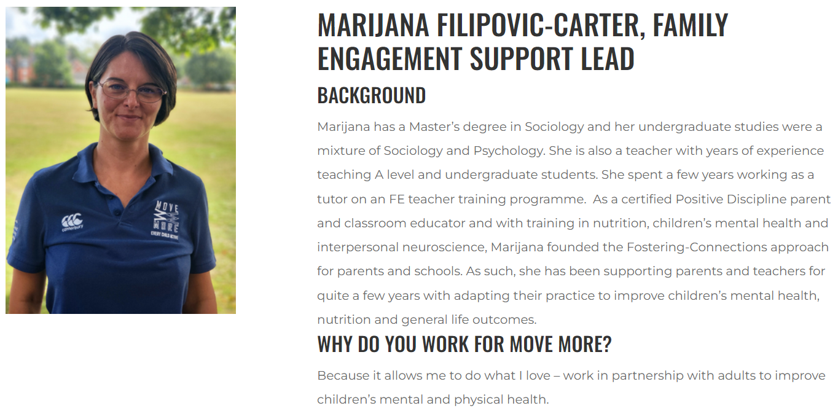
PP lead responsibilities  To lead a whole school programme to improve the outcomes for disadvantaged pupils and to narrow the gap with others in school.  Design, implement, monitor and evaluate the whole school programme.  To identify and analyse current patterns of vulnerability of pupils in our school  To be responsible for the deployment of additional resources targeted at improving outcomes for disadvantaged pupils, and to monitor and evaluate its impact. Identify and analyse data  To research and design an effective whole school programme to support progress.  To plan and organise the delivery of 1:1 tuition across all ages.  To meet regularly with SENDCo and pastoral lead  To liaise with teachers and /or pastoral staff regarding pupils’ outcomes/progress.  To provide regular reports/information re pupils’ progress to Headteacher and Governors termly.  To identify and adopt the most effective teaching approaches suitable for a varied selection of children.  Evaluate the impact of the quality provisions for FSM pupils through pupil voice, data analysis, work scrutiny, teacher feedback, and parent carer feedback to identify successful approaches in school.  To participate in the performance and development review process, taking personal responsibility for identification of learning, development and training opportunities in discussion with SLT. | https://d2tic4wvo1iusb.cloudfront.net/documents/guidanceForTeachers/EEF-Guide-to-the-Pupil-Premium-Autumn-2021.pdf  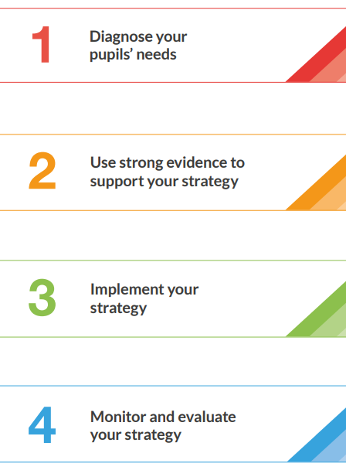  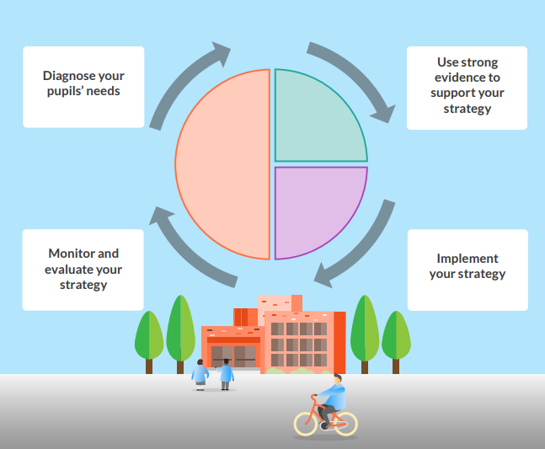

Wider strategies (for example, related to attendance, behaviour, wellbeing)
Budgeted cost: £ 26,107
Activity | Evidence that supports this approach | Challenge number(s) addressed
Subsidize the cost of residential visits  Subsidize the cost of residential visits for PPG/LAC children in Y5 and Y6  Ensure that PP children have the same opportunities for enrichment outside of the curriculum that non PP children get through supporting the funding of school residential.  Timing and venue of Y6 trip has been changed to reduce the cost for families | There is a wider evidence base indicating that outdoor adventure learning may have positive impacts on other outcomes such as self-efficacy, motivation and teamwork. Outdoor adventure learning may play an important part of the wider school experience, regardless of any impact on academic outcomes.  https://educationendowmentfoundation.org.uk/education-evidence/teaching-learning-toolkit/outdoor-adventure-learning  Outdoor Adventure Learning might provide opportunities for disadvantaged pupils to participate in activities that they otherwise might not be able to access. Through participation in these challenging physical and emotional activities, outdoor adventure learning interventions can support pupils to develop non-cognitive skills such as resilience, self-confidence and motivation.  The application of these non-cognitive skills in the classroom may in turn have a positive effect on academic outcomes. However, the evidence base linking non-cognitive skills and pupil attainment is weak and schools should therefore carefully evaluate the impact of outdoor learning interventions on pupil achievement, if this is the intended outcome.  https://educationendowmentfoundation.org.uk/education-evidence/teaching-learning-toolkit/outdoor-adventure-learning | 5, 7, 9
Subsidize the cost of sporting and after school clubs/trips/music tuition  (£600)  Ensure that PP children have the same opportunities for enrichment outside of the curriculum that non PP children get through subsidizing the cost of school based clubs/afterschool clubs/trips that may require payment.  Audit the participation of Pupil Premium children in school clubs and extra-curricular activities, e.g. swimming, cycling.  Forest School will be used more widely throughout the school. | Arts participation approaches can have a positive impact on academic outcomes in other areas of the curriculum.  2. The research here summarises the impact of arts participation on academic outcomes. It is important to remember that arts engagement is valuable in and of itself and that the value of arts participation should be considered beyond maths or English outcomes.  Wider benefits such as more positive attitudes to learning and increased well-being have also consistently been reported.  https://educationendowmentfoundation.org.uk/education-evidence/teaching-learning-toolkit/arts-participation  Outdoor Adventure Learning might provide opportunities for disadvantaged pupils to participate in activities that they otherwise might not be able to access. Through participation in these challenging physical and emotional activities, outdoor adventure learning interventions can support pupils to develop non-cognitive skills such as resilience, self-confidence and motivation.  The application of these non-cognitive skills in the classroom may in turn have a positive effect on academic outcomes. However, the evidence base linking non-cognitive skills and pupil attainment is weak and schools should therefore carefully evaluate the impact of outdoor learning interventions on pupil achievement, if this is the intended outcome.  https://educationendowmentfoundation.org.uk/education-evidence/teaching-learning-toolkit/outdoor-adventure-learning | 5, 9
Parent/Pupil Liaison project (£15,439)  22 hours per week HLTA KW  Support Mentor Learning Programme  A higher level of parent involvement with school enables effective support  Target pupils make good progress and begin to close the attainment gap. 1:1 time given to all pupil premium children.  Monitor and refine systems in place to help us to identify those families who may need some additional support.  To support our families through the pastoral team at school as well as accessing external agencies, e.g. Early Help, Young Minds Matter.  Continue to use our Family Support Worker to lead parent information sessions and to provide targeted intervention where needed, e.g. parent workshops, individual support such as routines within the home. | Embedding principles of good practice set out in the DfE’s Improving School Attendance advice.  The DfE guidance has been informed by engagement with schools that have significantly reduced levels of absence and persistent absence.  https://educationendowmentfoundation.org.uk/education-evidence/evidence-reviews/attendance-interventions-rapid-evidence-assessment  This rapid evidence assessment examines the existing research on interventions that aim to improve pupils’ school attendance and the characteristics of these interventions, based on a systematic search of existing literature.  https://d2tic4wvo1iusb.cloudfront.net/documents/pages/Attendance-REA-report.pdf?v=1647348064  There is some evidence of promise for several strategies including parental engagement approaches and responsive interventions that target the individual causes of low attendance Positive impacts were found for both parental communication approaches and targeted parental engagement interventions. The impact was larger for targeted approaches. Responsive intervention in which a member of staff or team use multiple interventions and target approaches specifically to the needs of individual pupils was also found to be effective. There may be crossover with these approaches and the approaches used in English schools by attendance officers. While these results are promising, the study quality means that they should be treated with caution. | 6, 7, 9
Attendance  Improve persistent absenteeism rates for pupils through targeted family support.  KW to work with families to support improvement with attendance, focusing on:  Promote the benefits of attendance across the school and with parents  Update attendance policy and share widely  Monitor attendance registers monthly  Analyse attendance and absence data weekly/monthly to identify pupils and cohorts that require support and put strategies in place  Use of attendance bench marking to ensure high expectations  Build strong relationships with families, listen to and understand barriers and work to support their removal  Support pupils with medical conditions and/or special educational needs/disabilities to attend school  Share information with Early Help, LA, Trust, other schools when behaviour is at risk of becoming persistent or severe  Create bespoke attendance improvement plans  Weekly update of attendance with TC admin  Data analysed and trends reviewed ans acted upon  Bench marking in place  Strong relationships built and supportive  Work with SEND and medical needs parents  Work with EH etc  Improvement plans for attendance are bespoke | Embedding principles of good practice set out in the DfE’s Improving School Attendance advice.  The DfE guidance has been informed by engagement with schools that have significantly reduced levels of absence and persistent absence.  https://educationendowmentfoundation.org.uk/education-evidence/evidence-reviews/attendance-interventions-rapid-evidence-assessment  This rapid evidence assessment examines the existing research on interventions that aim to improve pupils’ school attendance and the characteristics of these interventions, based on a systematic search of existing literature.  https://d2tic4wvo1iusb.cloudfront.net/documents/pages/Attendance-REA-report.pdf?v=1647348064  There is some evidence of promise for several strategies including parental engagement approaches and responsive interventions that target the individual causes of low attendance Positive impacts were found for both parental communication approaches and targeted parental engagement interventions. The impact was larger for targeted approaches. Responsive intervention in which a member of staff or team use multiple interventions and target approaches specifically to the needs of individual pupils was also found to be effective. There may be crossover with these approaches and the approaches used in English schools by attendance officers. While these results are promising, the study quality means that they should be treated with caution. | 6, 7, 9
£300  Trips and resources for pupil premium work across the school and to meet children’s needs  Resources for anger management, sadness, communication resources.  PE kit/popcorn club/Book Bags etc  £500  Milk for PP children  £200  Support for new pupil premium children including Reception  Support identified by PP team for new pupils and Reception pupils who will not have been identified for funding | Maslow’s humanist perspective emphasized the importance of promoting the innate goodness inside all people.  From Maslow’s perspective, goodness needs to be nurtured by providing learners with a safe and fulfilling learning environment.  Perhaps Maslow’s most influential idea was his hierarchy of needs. To Maslow, we all have a range of needs that should be met in order to bring out the best in ourselves. Those needs are:  Physiological needs: At the base of Maslow’s pyramid are the physical requirements for life, including food, water and clothing.  Safety needs: Students need to feel safe and secure in order to focus on learning.  Belongingness needs: A feeling of inclusion and membership in a classroom community can help students enjoy coming to school.  Esteem needs: Students need to feel their teachers and peers have positive regard for them. Similarly, students should feel good about themselves and their own ability to succeed.  Self-Actualization: Also known as self-fulfilment, this need is met when students are achieving to the best of their abilities in the classroom.  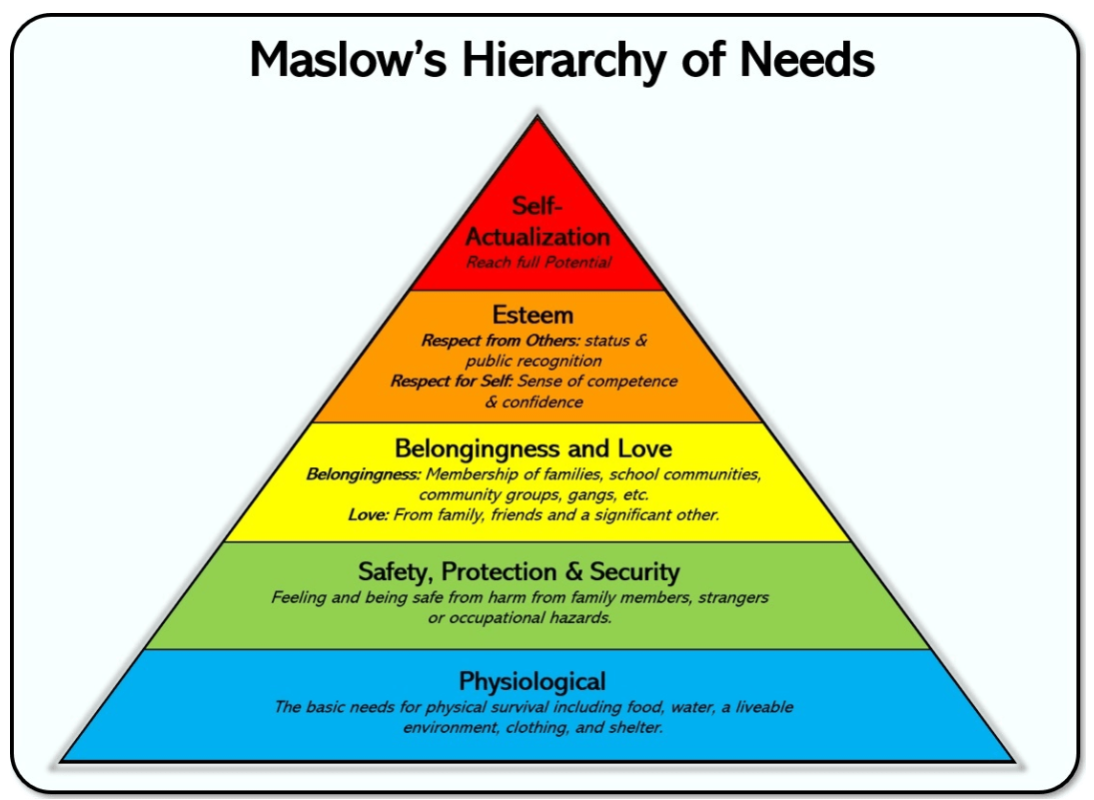 | 5, 6, 7, 9

Total budgeted cost: £ 39,878

Part B: Review of outcomes in the previous academic year

Pupil premium strategy outcomes
This details the impact that our pupil premium activity had on pupils in the 2021 to 2022 academic year.
How can oracy benefit your pupil premium students? On entry to school, children from low income families’ spoken language development is, on average,17 months behind children in the highest income group. Left unattended, this gap widens as they move through school. But, it doesn't have to be this way. As a Voice 21 Oracy School, we will support you to implement oracy education so that your students learn the oracy skills they need to succeed in school and in life.

Data and Statutory Assessments
Pupil Premium Outcomes:

EYFS
5/7 GLD
One child a concern throughout the year. Both children have received additional support for interventions.
Phonics Screening Check:
Y1 Phonics Screening Check
50% (2/4) passed.
2 X complex SEND did not pass but scores increased during the year. One of these applied for EHCP.
Y2 Phonics Screening Check:
2 X Phonics screening re-take. 100% passed (31 to 37 and 24 to 39)
End of KS1
Only 2x PP children.
Year 4 Multiplication Check
 | All | Pupil Premium | Non Pupil Premium
Average Score | 22 | 21 | 23
% full marks | 37% | 29% | 38%
% >20 | 78% | 57% | 81%

End of KS2
6x PP children (2 x SEN, 1 X SEN/EAL, 1 X CIN, 2 X SEMH)
 | Percentage of pupils achieving the expected standard |  |  | Average scaled score
 | School | Pupil Premium | Nationally | School | Nationally
Reading | 80% | 50% | 73% | 106 | 105
GPS | 78% | 50% (17%) | 72% | 104 | 105
Maths | 70% | 33% | 73% | 103 | 104
Writing | 75% | 50% | 71% | N/A | N/A
Science | 78% | 50% | 80% | N/A | N/A

Progress for PP children from EYFS-Y6
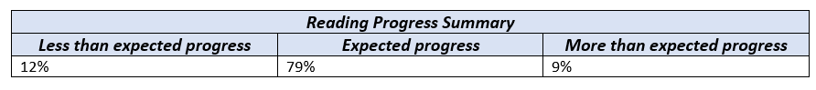
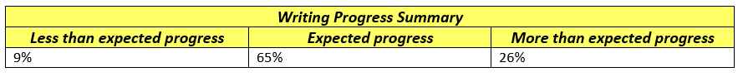

Teaching
Neurodiversity INSET in September 2022 run by Colin Foley from the ADHD Foundation: Staff attended CPD on neurodiversity and how to make classrooms neurodiverse aware and friendly. Focused on the range of difficulties that children might present with including ADHD, ASD, Dyspraxia and also children who struggle with cognitive load, memory and attention span. Linked on our approaches of emotion coaching and Kagan Structures. This built further confidence in meeting children’s diverse needs. Learning walks have shown that these strategies were supporting children to make progress and engage with their learning.

Been part of several GLOW Maths TRGs:
- Oracy in Mathematics
- Y5-Y8 Maths Continuity Work Group
- Developing, Embedding & Sustaining Mastery in Maths Teaching and Research Group
- Specialist Knowledge for Teaching Mathematics TA Programme – TRG
CPD Steve Lomax – problem solving, reasoning
These have enabled children to approach problems with more confidence whatever their starting points. Manipulatives are being used more widely to represent concepts and are used in interventions.

See CDP forms for impact of CPD on individual staff and outcomes for children.

Oracy
CPD for all teaching staff on developing the use of oracy in the curriculum (started to implement Voice 21 strategies and will further embed next year)

Vocabulary is an integral part of our long term planning documents and curriculum end point documents. Kagan structures have been used to support development of vocabulary. Two member of staff have been attending Voice 21 CPD and have been using the approaches with their classes. This now needs to be introduced across the school.
Fidelity to the long term curriculum planning documents has ensured a more consistent use of vocabulary and we have been looking at the key concepts that weave through subjects, e.g. history. This is supporting the children in knowing and remembering more.

Voice 21 and the ongoing oracy focus has given children the opportunity to explicitly and purposefully develop crucial skills in spoken language. All pupils are therefore able to access and benefit from a high-quality oracy education. The children are using the ‘Talk Tactics’ to express their ideas as well as the sentence stems in maths. Children are able to make more connections and articulate their depth of understanding

ELS
ELS is being used as our validated phonics scheme and all staff across the school completed the ELS training. There has been support from the English Lead who is now the Lead Practioner for Phonics for DGAT. There is evidence that ELS has improved the teaching of phonics within our school and this needs to be further embedded during 2023-24. All children made progress with their phonics, including those with SEND. XX% passed the PSC Interventions are being used across all Key Stages ensuring there is a consistent approach when supporting children. PSC results

Maths
There was an increase the number of children achieving GDS at the end of KS2. We developed the opportunities for children to show evidence of greater depth in lessons and assessments, e.g. DNA to fully provide explanations.

Targeted Interventions
Social and Emotional
There were TAs (equivalent to two days a week) to provide targeted social and emotional support in EYFS, KS1 and KS2, e.g. Drawing and Talking. These interventions were planned out every half term by pastoral team in response to the needs of the children and any gaps in learning, e.g. academic, Fizzy, cooking, social and emotional. Positive relationships were formed, children’s confidence grew, they felt more ready to access the work in class, they developed strategies to support themselves when things were difficult and they were experiencing big feelings (see Pupil Voice)

Phonics
We had additional phonics sessions targeted at disadvantaged pupils who required further phonics support. We employed a teacher who worked in KS1, 4 days a week releasing the class teachers so that they could teach additional phonics in Y1/2. Our PSC results showed progress but were not quite in line with the national level in Y1. 100% pass rate in Y2 for PP children.

KS2 Interventions (10x afternoons per week)
Gaps have been identified by teachers following lessons and assessments and used to inform interventions during the afternoon sessions. These interventions have been planned during our PIC meetings and have been used for phonics, reading, writing and maths. There have been positive outcomes for the children (see Phase Data Reports). The data shows that more of our disadvantaged children are making less progress in Maths than English. Interventions will be implemented to address any gaps in learning in Autumn 2022 and will be planned in PICS.

School Led Tutoring
This did not take place this year after reviewing the impact on outcomes from the previous year. Reduced funding also made this challenging to implement

Booster Group for Maths (Y6)
Booster group – 19 x children (68% EXP)
This was carried out before school on a Tuesday, with breakfast provided, Children were extremely committed to the group and made progress as a result as shown by the increase in their assessment scores, with 13 children reaching ARE despite not being on target to do so in Terms 1 and 2. There were 8 weeks. Next year we will start earlier and do 10 weeks.

Forest School with Chris Oakey (see Floor Book for specific examples)
There have been many positive impacts for children who have been engaged with Forest School. Some pupil premium children have had sessions all year to support their social and emotional needs whereas others have participated with their classes.
Pupil Voice (see examples)
Positive impacts:
Self-awareness – supported children to be more aware of their physical selves, to safely explore and test their own boundaries. They have developed skills, tested ideas and made discoveries.
Self-regulation – children have experienced the emotions that go with challenging themselves, taking risks, achieving something and failing at something. By providing a safe environment in which to experience these emotions, children have been learning how to manage them successfully.
Social skills – is has been a natural place to promote working together, sharing tools and playing together, operating outside of the constraints or rules of the classroom. Children have collaborated and collectively achieved goals. This has been particularly powerful for our EAL children who started the year with no spoken English.
Empathy – this has developed through supporting each other and developing an understanding that some things may be more challenging for some members of the team than others.
Motivation – Chris has developed a fascinating environment for children to play and learn in. Curiosity and keenness to explore often trigger an eagerness to participate, freedom from “being wrong” and willingness to have a go.
Many of these areas have transferred into learning inside the classrooms. There have been improved attitudes to learning, increased motivation, more willingness to have a go and greater resilience. Y6 PP children who were part of the afternoon group, supported EYFS during T6 really developing their communication skills, self-esteem and sense of purpose.

Wider Strategies
Family Support Worker – Move More
Family Engagement and Support Impact Summary for
2022/23

6 Webinars  (Number of parents registered) | 77
8 school specific webinars (Number of parents who attended live and accessed the recordings) | 131
Health challenges (number of challenges shared) | 3 (Tame your worry brain & Bake and Shake & Hop, skip and Hydrate)
1-1 Support (number of families) | 14
Newsletters (number shared with the school) | 6
No of parents that attended coffee mornings and f2f parent sessions | 67
TA session (number of sessions) | 1
Total number of families engaged in direct contact | 289

Webinars:
- How to help children with big feelings (Term 1)
- How to raise and confident children (Term 2)
- Snug as a bug - encouraging good sleeping habits for the whole family (Term 3)
- How to raise independent children (Term 4)
- Consequences, punishment and rewards - what works and what doesn't (Term 5)
- Siblings (without the) Rivalry (Term 6)
Newsletters:
- After-school restraint collapse (Term 1)
- Tips for managing your child's routine during the holidays season (Term 2)
- How to encourage children to do homework (Term 3)
- Mobile phone etiquette and how to deal with unkind and hurtful content (Term 4)
- Sleep disturbances in children (Term 5)
- Managing sibling rivalry during the summer holidays (Term 6)
Health Challenges:
- Tame your worry brain programme (Terms 1 and 2)
- Bake and shake (Terms 3 and 4)
- Hop, skip and hydrate (Terms 5 and 6)
School specific face-to-face sessions and webinars:
- The afterburn of starting school (Term 1)
- Tame Your Worry Brain (Term 2)
- Managing tantrums and meltdowns (Term 3)
- Q&A session for TAs (Term 3)
- Understanding your “Tweenagers” (Term 4)
- How to help your child build self-esteem (Term 6)
- Helping your child be “school ready for September (Term 6)
- How to help your child transition to secondary school (Term 6)

Feedback from parents on webinars and newsletters:
“Thank you so very much for today and for the previous session also.
I’m honestly finding your help and support to be invaluable and listening to you and putting these suggestions into action really is seeing results.
I appreciate very much all that you are doing.”

“What a brilliant newsletter that you have put together and been sent out to us today. Easy to read and so informative. Thank you!”

“We do follow with great interest your info you send out for parents- the online sessions that can be logged into and viewed at a later time are particularly helpful.
Thanks for all you are doing.”

“I just wanted to say how glad I was to have the opportunity to have joined your session at school on Monday, I found the session and the recording of the evening’s session so helpful. Both my husband (who works away all week) have both managed to watch it and will be implementing so many of your suggestions into our family and home.”

There are details about the impact of one to one support provided to families in the full impact summary document.

Emotion coaching
Emotion coaching and approaches outlined in our relationships policy have been used widely which has maintained positive relationships across the school.

Young Minds Matter
Young Minds Matter support is being accessed by children when appropriate in school. This has been incredibly valuable and supportive with tangible improvements for individuals. Children are able to access the support from YMM and TIC+. Last year XXX children accessed this support.

Pastoral Lead
Sessions with our pastoral lead have supported the emotional needs of pupils so that they make better progress in their learning and are able to feel calm and ready to learn. The children’s personal, social and emotional development has been supported, as well as their communication and language skills.

Signposting, GCC website, Early Help have supported children and their families.
PaId for PP children’s milk
We have ensured that PP children have the same opportunities for enrichment outside of the curriculum that non PP children get through supporting the funding of school based clubs/afterschool clubs/trips that may require payment. This has included Move More holiday clubs being provided for some families.
We have supported the funding of school residential. All PP children were able to take part in Y5 and Y6.

PP children have been part of many clubs, e.g. Cheltenham Town Football, Forest School, which has had a positive impact on them socially, emotionally and in terms of their well-being.

Attendance
We have improved persistent absenteeism rates for pupils through targeted family support and rigorous monitoring od attendance. Regular meetings between pastoral team, DHT, HoS and Exec Head focused on vulnerable children and attendance meant we were proactive at addressing any concerns and supporting families. Overwhelming success with improving attendance over the year (see minutes of meetings)

Externally provided programmes
Programme | Provider
Voice 21 Oracy Project | Voice 21
NELI – Nuffield Early Learning Intervention | Nuffield
Neurodiversity and how to make classrooms neurodiverse aware and friendly | Colin Foley from the ADHD Foundation
Oracy in Mathematics | GLOW Maths Hub
Y5-Y8 Maths Continuity Work Group | GLOW Maths Hub
Can Do Maths | Buzzard Publishing
Specialist Knowledge for Teaching Mathematics TA Programme - TRG | Centre for Literacy in Primary Education
Essential Letters and Sounds | Oxford University Press

Service pupil premium funding (optional)
Measure | Details
How did you spend your service pupil premium allocation last academic year? | Interventions to provide pastoral support. We identified any needs and gaps which we addressed with targeted support.
What was the impact of that spending on service pupil premium eligible pupils? | Children appeared settled, engaged and built positive relationships.

Further information (optional)
Use this space to provide any further information about your pupil premium strategy. For example, about your strategy planning, or other activity that you are implementing to support disadvantaged pupils, that is not dependent on pupil premium or recovery premium funding.

